Question1

1.

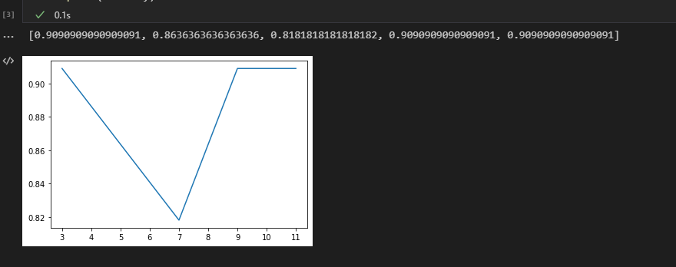

K = 3,9,11 gives highest accuracy in year 1

2.

I use k = 3,9,11 separately to predict the labels and find out that k = 3 gives the highest accuracy, which is 85%

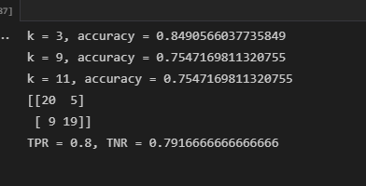

3.



5.

Using labels gives higher amount of return.

